PHP TRAININ

HTML - Hyper Text Markup Language

-**By** Tim Berners Lee, in **1991**

In 1993**, HTML+**

in 1995, **HTML 2.0**

in 1997, **HTML 3.2**

in 1999, **HTML 4.01**

in 2000, **HTML XHTML**

in 2010, **HTML 5**

1. **Meta**

<meta name="viewport" content="width=device-width, initial-scale=1.0">

**1. Document Structure**

1. Head tag - *title*
2. Body tag - *main content*

**2. Tag**

1. paired Tag – *head, heading tags, html, body, title, paragraph, underline*

2. Self closing Tag – *new line<br/>, image, horizontal line, comment tag*

3. Text Formeting Tag- *bold(b), italic(i)*

**3. Attributes**

1. style

<p style=”color:red;background:black;font-size:20px;”>

**4. Marquee Tag**

Attribute

1. Behavior - *Scroll, slide, alternate*

2. Direction – *Left, Right, Top, Bottom*

3. Scrollamount – *1 to so on*

4. Hspace - *__px*

5. Vspace - *__px*

**5. Horizontal line**

1. Hspace - *__px*

2. Vspace - *__px*

**6. lists**

1. Description List

Dl – *descriptioni list*

Dt – *description term*

Dd – *description data*

2. Ordered List

Ol – *ordered list*

Li – *list item*

3. Un-ordered List

Ul – *unordered list*

Li – *list item*

**span tag**

Rules

1. Don’t have height and width attribute
2. It don’t aligned
3. It display as inline
4. It not use margin.

**Div tag**

Rules

1. It have height and width attribute
2. it don’t aligned
3. it display as block
4. it use margin.

|  |  |
| --- | --- |
| **Span tag** | **Div tag** |
| 1. Don’t have height and width attribute 2. It display as inline 3. It don’t use margin | 1. It have height and width attribute 2. Display as block 3. It use margin |

**7. Table**

Table – *table start*

Tr – *table row*

Th – *table heading*

Td – *table data*

Attributes

1. cellspacing

2. cellpadding

3. rowspan

4. colspan

5. bordercolor

**8. HTML Entities**

In HTML reserve word for special character is called entities

*&entity name;*

1. &lt – *less then*

2. &gt- *greater then*

3. &nbsp – *space*

4. &amp - *&*

5. &copy – *Copyright*

6. &reg - *Register*

**9. forms**

Form – (*form start) – method=post/gest, action=url, name=name*

Input – (*input box or text box) – type=text/password/email/checkbox/submit/button/radio, name*

Select – (*options) - name*

Textarea –(*text box) – name, rows, cols*

**10. input tag**

Attributes

1. Type
2. Text
3. Radio
4. Email
5. Password
6. Submit
7. Button
8. File
9. Name
10. Height
11. Width

**Textarea**

Attributes

1. Rows
2. Cols

**10. Required Attribute in input form**

<input type=”text” required=””>

Here this input not contail null value

**11. Pattern Attribute**

<input type=”text” pattern=”.{8,}” title=”must contain atleast 8 or more”>

<input type=”text” pattern=”[0-9]{10}” title=”must contain only 10 number”>

**12. external stylesheet**

<link rel=”stylesheet” href=”style.css”>

**13. a tag**

Target attribute

<a href=”abc.html” target=”_blank”>go to next windows</a>

Jump in page bookmark (id)

<a href="#C4">Jump to Chapter 4</a>

<h2 id="C1">Chapter 1</h2>

<h2 id="C2">Chapter 2</h2>

<h2 id="C3">Chapter 3</h2>

<h2 id="C4">Chapter 4</h2>

<h2 id="C5">Chapter 5</h2>

**14. tags for text**

code

<code>  
x = 5;<br>  
y = 6;<br>  
z = x + y;  
</code>

Preserve tag

<pre>  
<code>  
x = 5;  
y = 6;  
z = x + y;  
</code>  
</pre>

Keyboard <kbd>

<p>Save the document by pressing <kbd>Ctrl + S</kbd></p>

Samp tag

<p>If you input wrong value, the program will return <samp>Error!</samp></p>

Var tag

Einstein wrote: <var>E</var> = <var>mc</var><sup>2</sup>.

Blockquote

<blockquote>Blockquote</blockquote>

**15.HTML Media**

VIDEO TAG

<video width="320" height="240" autoplay>  
 <source src="movie.mp4" type="video/mp4">  
  <source src="movie.ogg" type="video/ogg">  
Your browser does not support the video tag.  
</video>

ATTRIBUTE

controls

autopay

**EXAMPLE IN JAVA SCRIPT**

<div style="text-align:center">

<button onclick="playPause()">Play/Pause</button>

<button onclick="makeBig()">Big</button>

<button onclick="makeSmall()">Small</button>

<button onclick="makeNormal()">Normal</button>

<br><br>

<video id="video1" width="420">

<source src="mov_bbb.mp4" type="video/mp4">

<source src="mov_bbb.ogg" type="video/ogg">

Your browser does not support HTML5 video.

</video>

</div>

<script>

var myVideo = document.getElementById("video1");

function playPause() {

if (myVideo.paused)

myVideo.play();

else

myVideo.pause();

}

function makeBig() {

myVideo.width = 560;

}

function makeSmall() {

myVideo.width = 320;

}

function makeNormal() {

myVideo.width = 420;

}

</script>

AUDIO TAG

<audio controls>  
<source src="horse.ogg" type="audio/ogg">  
 <source src="horse.mp3" type="audio/mpeg">  
Your browser does not support the audio element.  
</audio>

PLUG INS

<object width="400" height="50" data="bookmark.swf"></object>

<object width="100%" height="500px" data="snippet.html"></object>

<object data="audi.jpeg"></object>

<embed width="400" height="50" src="bookmark.swf">

<embed width="100%" height="500px" src="snippet.html">

<embed src="audi.jpeg">

YOUTUBE PLUG IN

<iframe width="420" height="315"  
src="https://www.youtube.com/embed/tgbNymZ7vqY">  
</iframe>

AUTOPLAY

<iframe width="420" height="315"  
src="https://www.youtube.com/embed/tgbNymZ7vqY?autoplay=1">  
</iframe>

CONTROL

<iframe width="420" height="315"  
src="https://www.youtube.com/embed/tgbNymZ7vqY?controls=0">  
</iframe>

USING EMD OR OBJECT

<object width="420" height="315"  
data="https://www.youtube.com/embed/tgbNymZ7vqY">  
</object>

<embed width="420" height="315"  
src="https://www.youtube.com/embed/tgbNymZ7vqY">

**16.**

--------------------------------------------end--------------------------------------------

CSS – Cascading Style Sheet

**1. Scale**

|  |
| --- |
| <html>  <head>  <title>scale</title>  <style>  #d  {  height:200px;  width:100px;  background-color:#00FF33;  }  #d:hover  {  -webkit-transform:scale(2,4); /*(x,y) */  transform:scale(2,4);  }  h1  {color:#FF0000}  </style>  </head>  <body>  <div id="d">  hello</div><nobr/>  <img src="file:///G|/mohit/documents/photos/ce0.jpg" id="d"/>  </body>  </html> |

**Output**

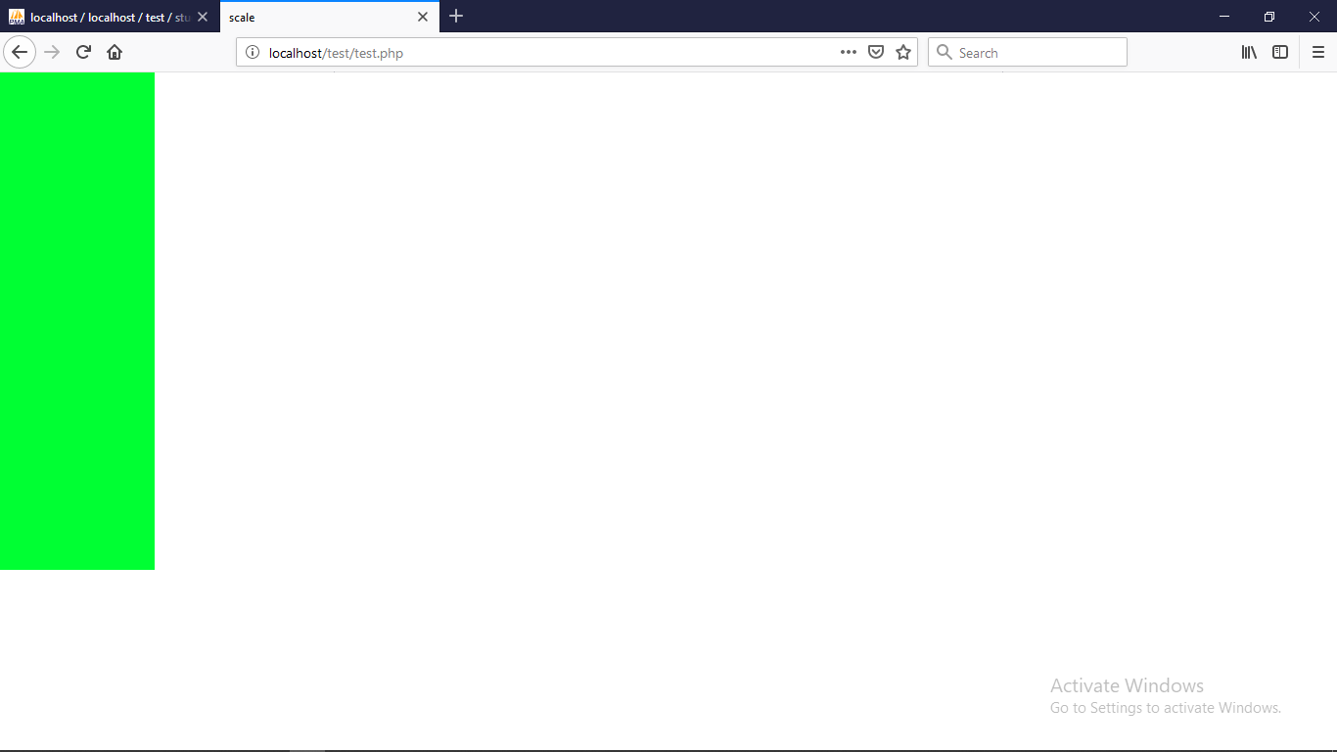

**2. Skew**

|  |
| --- |
| <html xmlns="http://www.w3.org/1999/xhtml">  <head>  <title>skew</title>  </head>  <style>  img  {  height:200px;  width:100px;  background-color:#00FF33;  }  img:hover  {  -webkit-transform:skew(30deg,30deg);  transform:skew(30deg,30deg);  }  </style>  <body>  <img src="file:///G|/mohit/examination/photos/exam2.jpg"/>  </body>  </html> |

**Output**

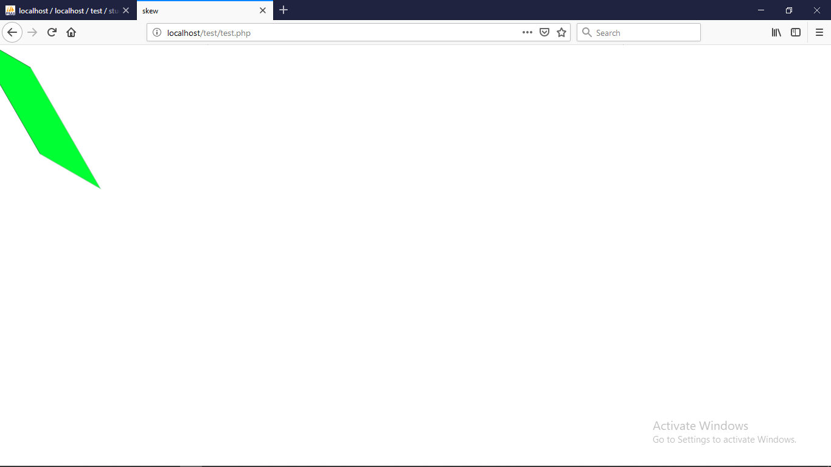

**3. z-index**

|  |
| --- |
| <html>  <head>  <title>z-index</title>  </head>  <style>  #a  {  height:100px;  width:100px;  background-color:#0033FF;  position:absolute;  }  #b  {  height:100px;  width:100px;  background:url(file:///G|/mohit/documents/photos/ce0.jpg);  z-index:1;  margin-left:50px;  }  </style>  <h1 id="a" src="file:///G|/mohit/examination/photos/exam3.jpg">hi</h1>  <img id="b" src="file:///G|/mohit/examination/photos/exam3.jpg"/>  <body>  </body>  </html> |

**Output**

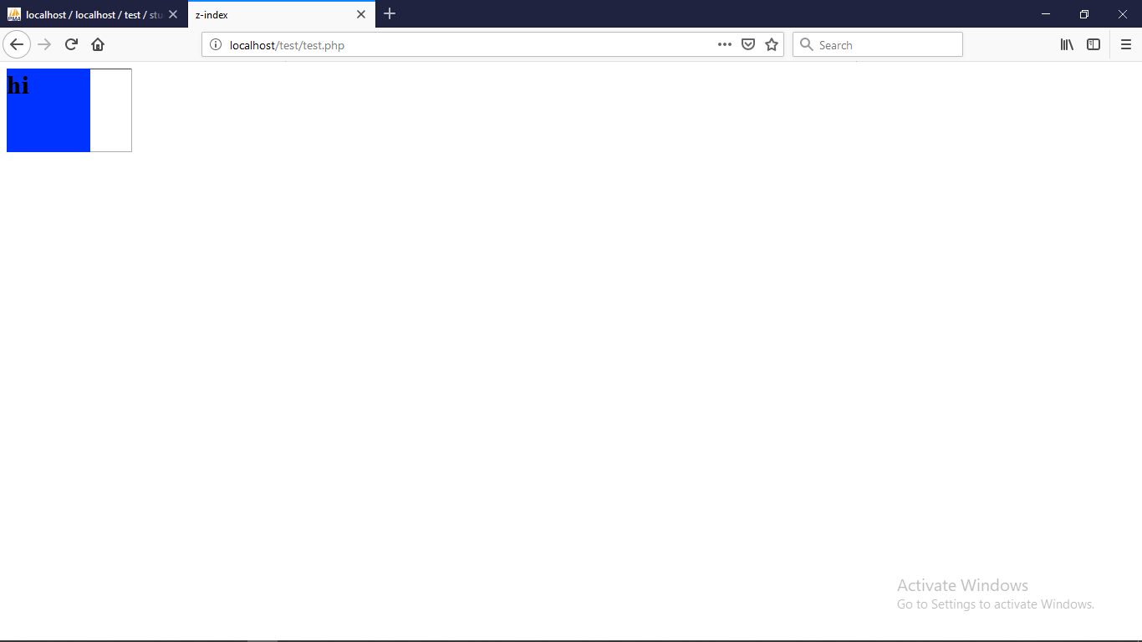

1. **Grid**

|  |
| --- |
| <html>  <head>  <title>Untitled Document</title>  </head>  <body>  <div style="background:-webkit-linear-gradient(90deg,green,white,white,orange);height:200px;width:100%"></div>  </body>  </html> |

**Output**

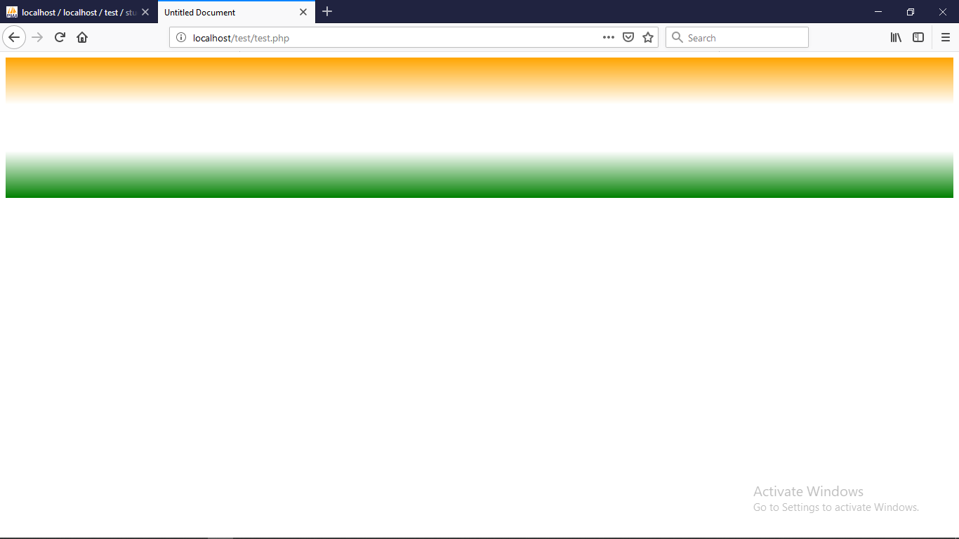

**5. Transform**

|  |
| --- |
| <html>  <head>  <title>transform</title>  </head>  <style>  div  {  width:300px;  height:400px;  background-color:#00FF00;  /*background:-webkit-transform:wait 1000s; */  }  div:hover  {  width:500px;  background-color:#FFFF00;  }  </style>  <body>  <div>a</div>  </body>  </html> |

**Output**

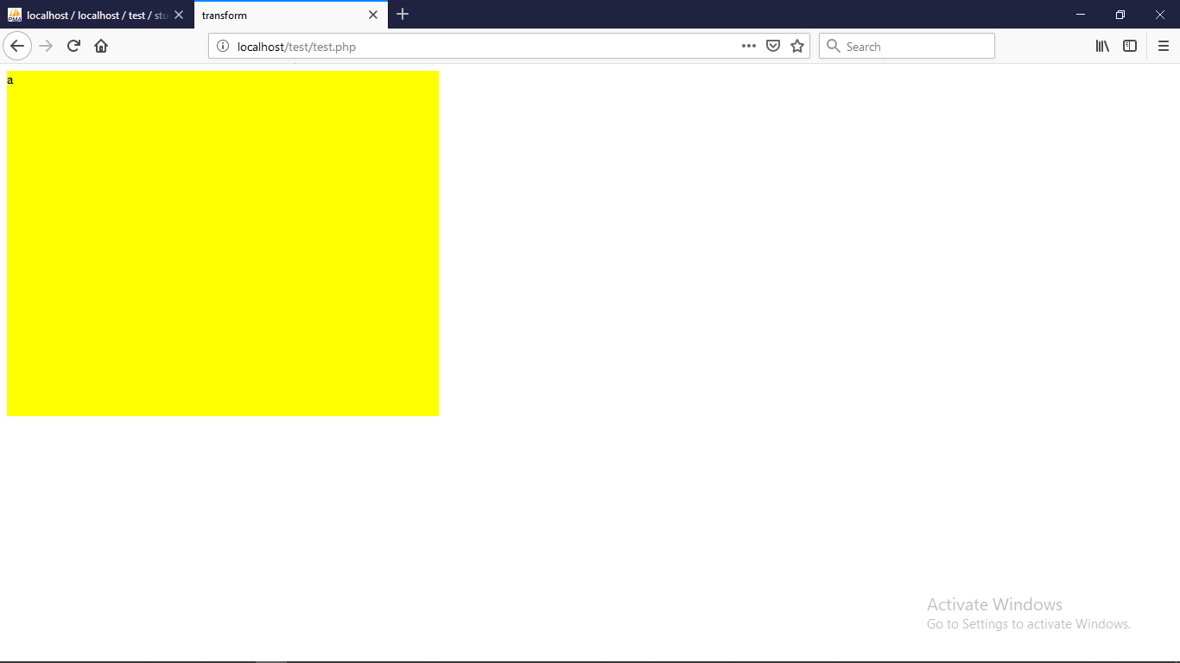

**6. Rotate**

|  |
| --- |
| <html>  <head>  <title>rotate</title>  </head>  <body>  <style>  div  {  height:200px;  width:100px;  background-color:#00FF33;  }  div:hover  {  -ms-transform:rotate(5deg);  -webkit-transform:rotate(5deg);  transform:rotate(5deg);  }  </style>  <div>  hello</div>  </body>  </html> |

**Output**

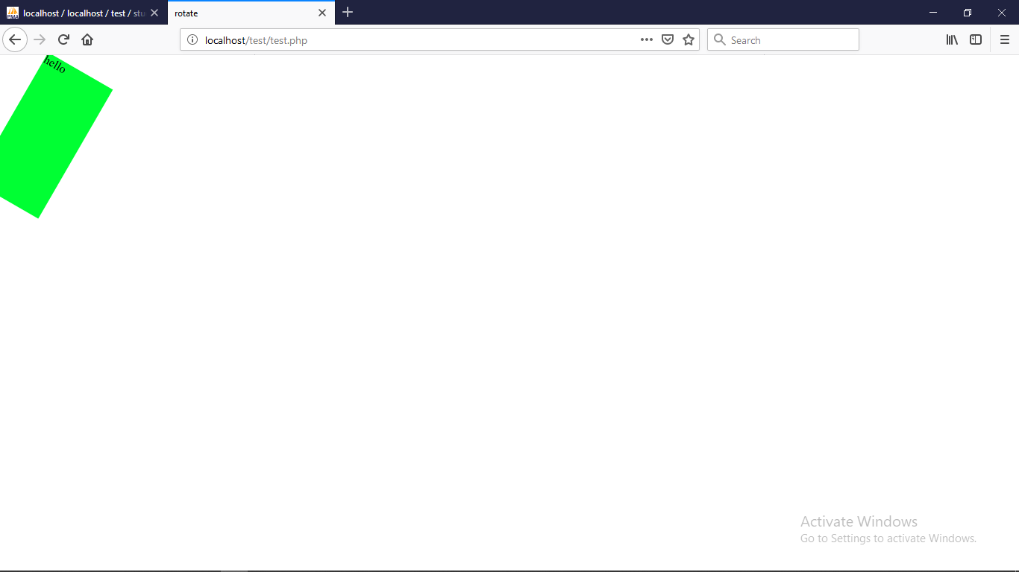

**7. Text style**

Text decoration

text-decoration:underline;

text-decoration:overline;

text-decoration:line-through;

Text transform

text-transform:capitalize;

text-transform:uppercase;

text-transform:lowercase;

text-transform:inherit;

Text shadow

text-shadow:#FFFFFF 1px;

Font varient

font-variant:small-caps;

Font family

font-family:Arial

font-family:"Times New Roman"

font-family:"Courier New"

font-family:Georgia

font-family:Verdana

font-family:Geneva

font-family:monospace

font-family:Helvetica

font-family:sans-serif

Font weight

font-weight:bold;

font-weight:200px;

**8. Border**

border-radius:15px;

border-right:#00FF00;

border-left:#00FF00;

border-style:hidden;

border:2px solid green;

**9. Lists**

list-style-image:url(../photos/bg2.JPG);

list-style:none; /*disc not show */

list-style-position:inside;

line-height:30px; /*list line space */

**10. Box Shadow**

box-shadow:2px 1px 2px 2px #CCCCCC;

**11. float**

|  |
| --- |
| <!DOCTYPE html>  <html>  <body>  <h2>Not Using object-fit</h2>  <p>Here we use do not use "object-fit", so when we resize the browser window, the aspect ratio of the images will be destroyed:</p>  <div style="width:100%;height:400px;">  <img src="1.jpg" alt="Norway" style="float:left;width:50%;height:100%;">  <img src="2.jpg" alt="Paris" style="float:left;width:50%;height:100%;">  </div>  </body>  </html> |

**Output**

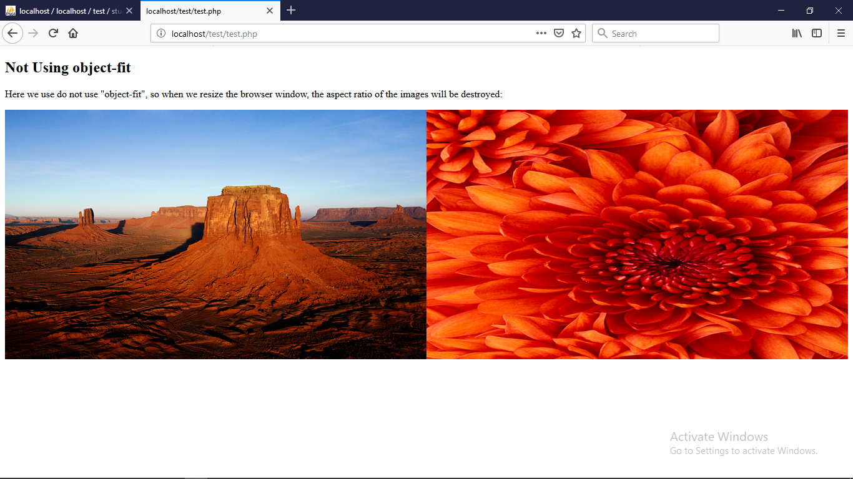

**12. Background**

background-image: url("img_tree.gif");

background-image: -webkit-radial-gradient(600px 200px, circle, #eee, #bababa 40%);

background-repeat: no-repeat;

background-attachment: fixed;

background-position: center;

Background blendmade

div {

width: 400px;

height: 400px;

background-repeat: no-repeat, repeat;

background-image: url("img_tree.gif"), url("paper.gif");

background-blend-mode: lighten;

}

Background clip

background-clip: border-box;

background-clip: padding-box;

background-clip: content-box;

Background origin

background-origin: content-box;

background-origin: padding-box;

background-origin: border-box;

Background size

background-size: auto;

background-size: 300px 400px;

background-size: 50%;

**vertical align**

vertical-align:top;

vertical-align:bottom;

vertical-align:middle;

vertical-align:sub;

vertical-align:super;

vertical-align:baseline;

**word-spacing and line-height**

|  |  |  |
| --- | --- | --- |
|  | **Line-height** | **Word-spacing** |
| Code / example | <pre style=”line-height:50px;”>  Ha ha  Ha ha  Ha ha  </pre> | <pre style=”word-spacing:20px;”>  Ha ha  Ha ha  Ha ha  </pre> |
| Output | Ha ha  Ha ha  Ha ha | Ha ha  Ha ha  Ha ha |

**Display**

display: inline; // for table

display:block; //

diplay:inline-block //

display:none; //hide - not require space after hide

visibility:hidden; //hide - require space after hide

**Opacity**

opacity: 0.5 //fade any image or background

**Transition**

|  |
| --- |
| <!DOCTYPE html>  <html>  <head>  <style>  div {  width: 100px;  height: 100px;  background: red;  -webkit-transition: width 2s, height 4s; /* For Safari 3.1 to 6.0 */  transition: width 2s, height 4s;  }  div:hover {  width: 300px;  height: 300px;  }  </style>  </head>  <body>  <div></div>  </body>  </html> |

**Output**

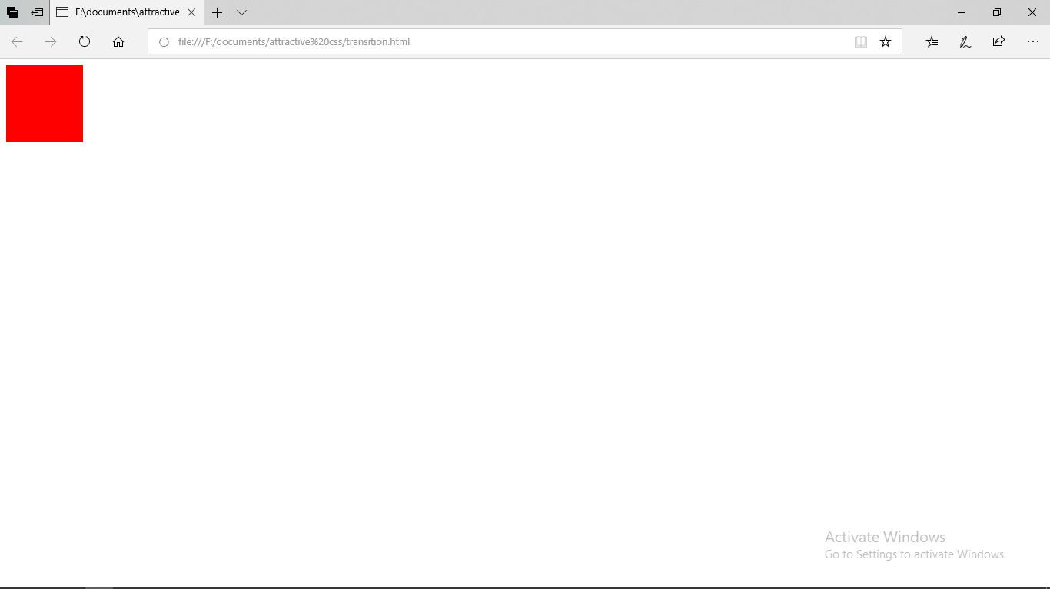

**Overflow**

Overflow:scroll; // over is scrolling in div / span with fixed height and width

Overflow: hidden; // over is hidden

Overflow:visible; //overwrite at outsite

---------------------------------------------end------------------------------------------------

JS – JavaScript

1. Javascript is a object based scripting language

2. Javascript Transformer is Browser

**Use**

1. to create interactive website

2. Client Side validation

3. Dynamic Dropdown Menus

4. Display Data and Time

5. Pop-up box, dialog boxes

6. Richer interface with html, css and php

7. Javascript is Dynamic Language – var a=10; var b=”aman”

Syntex

*<script >code</script>*

Attributes

1. Language – *javascript*

2. Type – *text/javascript*

3. src = *url*

Sections

Head Section – outside body

Body Section – inside body

**1. Output operator**

*Document.write(“hello”);*

**2. Variables**

*Var a=10;*

*Var b=”submit”;*

var x = new String();        // Declares x as a String object  
var y = new Number();        // Declares y as a Number object  
var z = new Boolean();       // Declares z as a Boolean object

*var A= undefined; //undefined variable*

**3. Data structure**

Primitive– String, Number, Boolean, Undefined

Non-Primitive – Object, Array, Regular-Expression

**4. Functions**

Simple Function

*<head>*

*<script>*

*function a()*

*{*

*Var a=10; //local variable*

*Document.write(a);*

*}*

*</script>*

*</head>*

*<body>*

*<script>a();</script>*

*</body>*

Function Display

function toCelsius(fahrenheit) {  
    return (5/9) * (fahrenheit-32);  
}  
document.getElementById("demo").innerHTML = toCelsius;

Functions Used as Variable Values

var x = toCelsius(77);  
var text = "The temperature is " + x + " Celsius";

//you can use function directly as a variable

var text = "The temperature is " + toCelsius(77) + " Celsius";

**5. Alert Box**

*Window.alert(“hello”);*

**6. Confirm Box**

*window.confirm(“do you want to save this password”);*

**7.Prompt Box**

*Var a=parseInt(prompt(“Enter the value”));*

*document.write(a);*

**8. Get element by id**

*document.getElementById(“a”).innerHTML=”hello”;*

*document.getElementById(“a”.)style.backgroundColor=””red”;*

document.getElementById("demo").style.fontSize = "35px";

document.getElementById('demo').style.display = 'none'; //for hide

document.getElementById("demo").style.display = "block"; //for unhide

document.getElementById("demo").innerHTML = 5 + 8;

lastname = "Peterson";

document.getElementById("demo").innerHTML = lastName;

**9.Append**

*<html>*

*<head>*

*<script src="jquery-1.10.2.js"></script>*

*<!--<script src="jQuery.Validate.min.js"></script>*

*<script src="jquery.transit.min (1).js"></script> -->*

*<script>*

*$(document).ready(function(){*

*$("#btn1").click(function(){*

*$("#a").append("<b>hello</b>");*

*});*

*$("#btn2").click(function(){*

*$("ol").append("<li>item</li>");*

*});*

*});*

*</script>*

*<title>append text and list</title>*

*</head>*

*<body>*

*<button id="btn1">append text</button>*

*<br/>*

*<button id="btn2">append item</button>*

*<p id="a">hello</p>*

*<ol>*

*<li>item1</li>*

*<li>item2</li>*

*<li>item3</li>*

*</ol>*

*</body>*

*</html>*

**10. Html and text**

*<html>*

*<head>*

*<title>html and text</title>*

*<script src="jquery-1.10.2.js"></script>*

*<!--<script src="jQuery.Validate.min.js"></script>*

*<script src="jquery.transit.min (1).js"></script>-->*

*<script>*

*$(document).ready(function(){*

*$("#btn1").click(function(){*

*alert("text" + $("#a").text);*

*});*

*$("#btn2").click(function(){*

*alert("html" + $("#a").html);*

*});*

*});*

*</script>*

*</head>*

*<body>*

*<p id="a">this is sum <b>of</b> numbers</p>*

*<button id="btn1">show text</button><br/>*

*<button id="btn2">show html</button>*

*</body>*

*</html>*

**11. Jquery**

*<html>*

*<head>*

*<script src="jquery-1.8.3.min.js"></script>*

*<!--<script src="jQuery.Validate.min.js"></script>*

*<script src="jquery.transit.min (1).js"></script>-->*

*<title>Untitled Document</title>*

*<script>*

*$(document).ready(function(){*

*$("#a").click(function(){*

*$(this).css("background-color","red");*

*});*

*$("#b").dblclick(function(){*

*alert("hello");*

*});*

*$("#c").mouseenter(function(){*

*$(this).css("color","blue");*

*});*

*$("#d").mouseenter(function(){*

*$(this).hide();*

*});*

*$("#e").mouseenter(function(){*

*$("#f").slideToggle();*

*});*

*});*

*</script>*

*</head>*

*<body>*

*<div id="a" style="height:50px; width:200px; border:solid">a</div>*

*<div id="b" style="height:50px; width:200px; border:solid">b</div>*

*<div id="c" style="height:50px; width:200px; border:solid">c</div>*

*<div id="d" style="height:50px; width:200px; border:solid">d</div>*

*<div id="e" style="height:50px; width:200px; border:solid">e</div>*

*<div id="f" style="height:50px; width:200px; border:solid; display:none">f</div>*

*</body>*

*</html>*

**12. consol log**

console.log(5 + 6);

**13. js objects**

*<script>*

*var person = {*

*firstName : "John",*

*lastName : "Doe",*

*age : 50,*

*eyeColor : "blue"*

*};*

*document.getElementById("demo").innerHTML =*

*person.firstName + " is " + person.age + " years old.";*

*</script>*

**14. typeof operator**

Typeof 1 // number

Typeof “abc” //string

**15. length of variable**

var str = ”hello”;

var len = str.length;

**16. Input from form**

<script>

var a=form1.value1.value;

document.write(a);

</script>

<form name=”form1” action=”#”>

<input type=”text” name=”value1”>

</form>

----------------------------------------------end----------------------------------------------

PHP – Hypertext Preprocessor

**Implode function**

Implode function is used to join elements of an array with a string

Example :-

|  |
| --- |
| <?php  $arr = array(‘I’, ‘am’, ‘Mohit’);  echo implode(“ “, $arr);  ?> |

**Explode function**

It is used to split a string by a specified string into pieces i.e. it breaks a string into an array.

Example :-

|  |
| --- |
| <?php  $str = “I am Mohit”;  print_r(explode(“ “,$str));  ?> |

**Date function**

date(format, timestamp)

Get Simple Date

d – Represents the day of the month (01 to 31)

m – Represents a month (01 to 12)

Y – Represents a year (in four digits)

l(Lowercase ‘L’) – Represents the day of the week

Get Simple Time

h – 12-hour format of an hour with leading zeros(01 to 12)

i – Minutes with leading zeros (00 to 59)

s – Seconds with leading zeros (00 to 59)

a – Lowercase Ante meridiem and Post meridiem (am or pm)

Example 1 : -

|  |
| --- |
| <?php  echo “Today is “.date(“Y/m/d”).”<br>”;  echo “Today is “.date(“Y-m-d”).”<br>”;  echo “Today is ”.date(“l”);  ?> |

Example 2 : -

|  |
| --- |
| <?php  echo “The time is ”.date(“h:i:sa”);  ?> |

**Create a Date with PHP mktime()**

mktime(hour, minute, second, month, day, year)

Example : -

|  |
| --- |
| <?php  $d = mktime(11, 14, 54, 8, 12, 2014);  echo “Created date is “.date(“Y-m-d h:i:sa”, $d);  ?> |

**PHP strtotime()**

The PHP strtotime() function is used to convert a human readable string to a Unix time.

Strtotime(time, now)

Example 1 : -

|  |
| --- |
| <?php  $d = strtotime(“10:30pm April 15 2014”);  echo “Created date is “.date(“Y-m-d h:i:sa”, $d);  ?> |

Example 2 : -

|  |
| --- |
| <?php  $d = strtotime(“tomorrow”);  echo date(“Y-m-d h:i:sa”, $d);  $d = strtotime(“next Saturday”);  echo date(“Y-m-d h:i:sa”, $d);  $d = strtotime(“+3 Months”);  echo date(“Y-m-d h:i:sa”, $d);  ?> |

**Include() function**

The include (or required) statement take all the text/code/markup that exists in the specified file and copies it into the file that uses the include statement.

Required will produce a fatal error (E_COMPILE_ERROR) and stop the script

Include will only produce a warning (E_WARNING) and the script will continue

Example 1 : -

|  |  |
| --- | --- |
| A.php   |  | | --- | | <?php  echo “hello”;  ?> | |
| b.php   |  | | --- | | <?php  echo “hy”;  include “A.php”;  echo “by”;  ?> | |

Example 2 : -

|  |  |
| --- | --- |
| A.php   |  | | --- | | <?php  $color = “red”;  $car = “BMW”;  ?> | |
| b.php   |  | | --- | | <?php  include “v.php”;  echo “I have a $color $car”;  ?> | |

**Array**

|  |
| --- |
| <?php  $cars = array(“maruti”, “BMW”, “nano”);  echo $cars[0];  echo $cars[1];  echo $cars[2];  #get length of array  echo count($cars);  ?> |

**Associative Array**

Associative array are the arrays that use named keys that we assign to them

These are two ways to create an associative array

Example : -

|  |
| --- |
| <?php  $age = array(“amit”=>”35”, “mohit”=>”25”, “rohit”=>”37”);  echo $age[‘amit’];  # or  $age1[‘amit’] = “34”;  $age1[‘mohit’]=”78”;  echo $age1[‘amit’];  ?> |

**For each loop**

The foreach loop looks only on array, and is used to loop through each value pair in the array

Example : -

|  |
| --- |
| <?php  $color=array('red','green','black');  foreach($color as $val)  {  echo "$val<br/>";  }  ?> |

**Dump function**

|  |
| --- |
| <?php  $a=8;  $b='mohit';  $c=56.9;  echo '<h4>Data type of variable a</h4>';  var_dump($a);  echo '<h4>Data type of variable b</h4>';  var_dump($b);  echo '<h4>Data type of variable c</h4>';  var_dump($c);  ?> |

**Exponential**

|  |
| --- |
| <?php  #3e4 == (3*10^4)  echo $a= 3e4;  echo '<br/><br/>';  $a='hello';  $b=$a."world"; #a=’hello’, b=’helloworld’  echo "$a and $b";  echo '<br/><br/>';  $a='hello';  $b=$a.="world"; #a=’helloworld’, b=’helloworld’  echo "$a and $b";  ?> |

**Stop execution of script**

|  |
| --- |
| <?php  echo “hello”;  exit();  echo “hy”; |

**String functions**

|  |
| --- |
| <?php  $a="hello world";  echo 'Enter a string<br/>';  echo $a;  echo "<br/>Length of entered string is ",strlen($a);  echo "<br/>World String Position function",strpos($a,'world');  ?> |

**Static variable**

|  |
| --- |
| <?php  $x=5; //global variable  function a()  {  $a=1; //local variable  static $b=1; //static variable  //echo $x;  echo "$a $b hello<br/>";  $b++;  }  echo "$x<br/>";  //echo $a;  a();  a();  a();  a();  ?> |

**Session functions**

1. $_SESSION[‘abc’]; //session variable
2. session_start(); //start session in a page
3. session_destroy(); // destroy session

**Get form contain value**

<a href=quiz.php?testid=1>basics</a>

Quiz.php page have $testid variable which have value 1 if you include extract($_GET); in this page;

**Readfile**

<?php  
echo readfile("webdictionary.txt");  
?>

**Global variable access**

|  |
| --- |
| <?php  $x = 75;  $y = 25;  function addition() {  $GLOBALS['z'] = $GLOBALS['x'] + $GLOBALS['y'];  }  addition();  echo $z;  ?> |

**PHP $_REQUEST FUNCTION**

|  |
| --- |
| <form method="post" action="<?php echo $_SERVER['PHP_SELF'];?>">  Name: <input type="text" name="fname">  <input type="submit">  </form>  <?php  if ($_SERVER["REQUEST_METHOD"] == "POST") {  // collect value of input field  $name = $_REQUEST['fname'];  if (empty($name)) {  echo "Name is empty";  } else {  echo $name;  }  }  ?> |

**Short array number**

|  |
| --- |
| <?php  $numbers = array(4, 6, 2, 22, 11);  echo "rsort<br>";  rsort($numbers);  $arrlength = count($numbers);  for($x = 0; $x < $arrlength; $x++) {  echo $numbers[$x];  echo "<br>";  }  ?>  <!--Sort Array (Ascending Order), According to Key - ksort()  -->  <?php  echo "<br><br>ksort<br>";  $age = array("Peter"=>"35", "Ben"=>"37", "Joe"=>"43");  ksort($age);  foreach ($age as $key) {  # code...  echo "$key<br>";  }  ?> |

**Output**

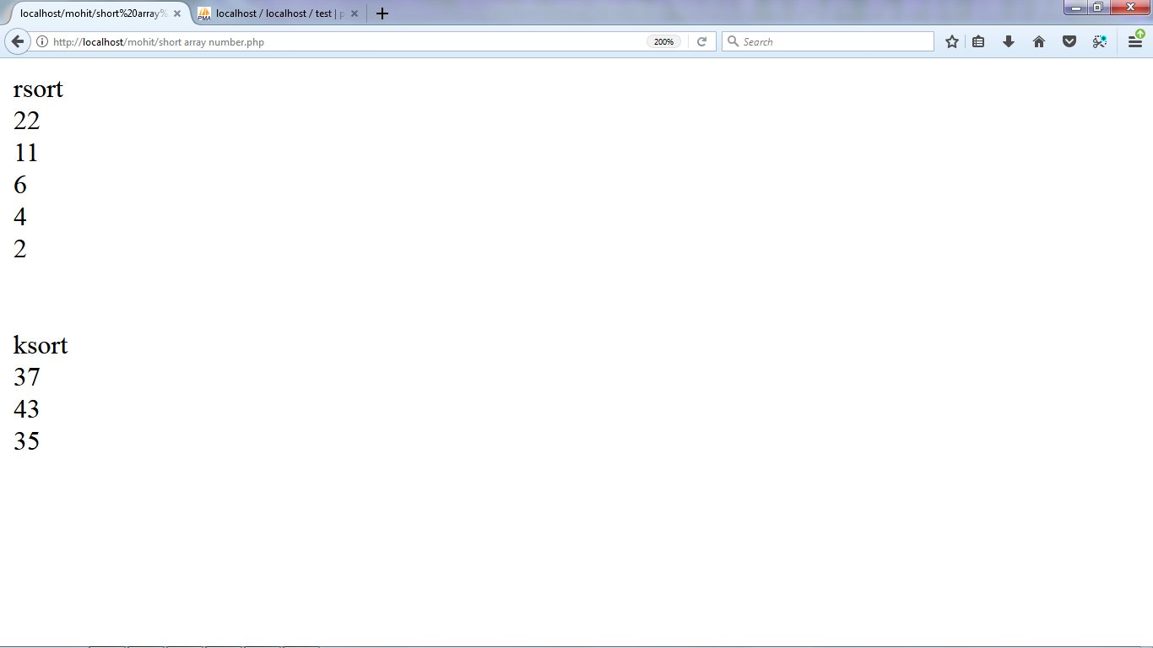

**Unset function**

Unset($_POST[‘abc’]);

Unset($_SESSION[‘abc’]);

**Database**

**Php form handling**

|  |  |
| --- | --- |
| Form.html   |  | | --- | | <html>  <head>  <title>Untitled Document</title>  </head>  <body>  <form action="welcome.php" method="post">  Name : <input type="text" name="name" /><br />  Email : <input type="text" name="email" /><br />  <input type="submit" />  </form>  </body>  </html> | |
| Welcome.php   |  | | --- | | <html>  <head>  <title>Untitled Document</title>  </head>  <body>  welcome <?php echo $_POST['name'] ?>. Your Email is <?php echo $_POST['email'] ?>.  </body>  </html> | |

**PHP form validation**

Validation of form is done to protect the form from hackers and spammers.

Validation Rules : -

Name → Must only contain a letters & whitespaces

Email → Must contain a valid Email address

Website → must contain a URL

Comment → multiline Input field

Gender → must select one.

**The form element**

The form tag is used to design forms. All the text field button, radio button etc comes under the form tag.

<form method = “post” action=”<?php echo htmlspecialchars($_SERVER[“PHP_SELF”]);?>”>

**$_SERVER[“PHP_SELF”]**

It is a super global variable that return the filename of the currently executing script. It sends the submitted form data to the page itself instead of jumping to a defferent page.

**Htmlspecial chars() function**

It converts special characters to HTML entities. It means that it will replace HTML characters like < and > with &lt; &gt;. This prevents hackers from exploiting the code.

**How to validate form data**

The 1st thing we will do is to pass all the variables through PHP’s htmlspecialchars() functions. It converts the special characters to HTML entities.

Eg. <script>location.href(‘www.rediff.com’)</script>

It would look like:

&lt; script &gt; location.href(‘[www.rediff.com](http://www.rediff.com)’) &lt; /script &gt;

We will do two more things when a user submits the form:

1. strip unnecessary characters (extra space, tab, newline) from the user input data using the PHP trim() function.
2. Remove backslashes (\) from the user input data with the PHP stripslashes() function.

**Example**

|  |
| --- |
| <!DOCTYPE html>  <html>  <head>  <title></title>  </head>  <body>  <?php  $name=$email=$gender=$comment=$website="";  if($_SERVER["REQUEST_METHOD"]=="POST"){  $name=test_input($_POST["name"]);  $email=test_input($_POST["email"]);  $gender=test_input($_POST["gender"]);  $comment=test_input($_POST["comment"]);  $website=test_input($_POST["website"]);  }  function test_input($data){  $data=trim($data);  $data=stripslashes($data);  $data=htmlspecialchars($data);  return $data;  }  ?>  <form method="post" action="<?php echo htmlspecialchars($_SERVER['PHP_SELF']); ?>">  Name : <input type="text" name="name"><br><br>  Email : <input type="email" name="email"><br><br>  Wesite : <input type="text" name="website"><br><br>  Comment : <textarea name="comment" rows="5" cols="40"></textarea><br><br>  Gender : <input type="radio" name="gender" value="female"> female <input type="radio" name="gender" value="male"> male <br><br>  <input type="submit" name="submit" value="submit">  </form>  <?php  echo "Your Input ";  echo "$name<br>";  echo "$email<br>";  echo "$website<br>";  echo "$comment<br>";  echo "$gender<br>";  ?>  </body>  </html> |

**Output**

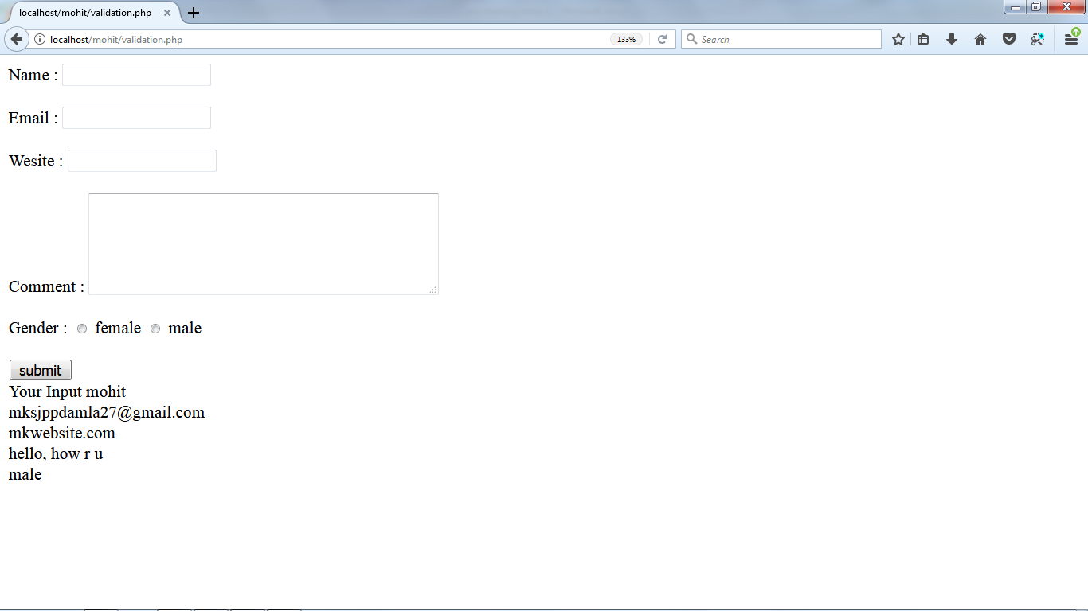

**Empty function**

PHP has empty() function to check wheither the value of a variable is empty or not.

**Example**

|  |
| --- |
| <html xmlns="http://www.w3.org/1999/xhtml">  <head>  <meta http-equiv="Content-Type" content="text/html; charset=iso-8859-1" />  <title>Untitled Document</title>  </head>  <body>  <?php  $nameerr=$emailerr=$gendererr="";  $name=$email=$gender=$comment=$website="";  if(empty($_POST["name"])){ //check either name field is empty or not  $nameerr="Name is Required ";  }  else{  $name=test_input($_POST["name"]);  }  if($_SERVER["REQUEST_METHOD"]=="POST"){  //$name=test_input($_POST["name"]);  $email=test_input($_POST["email"]);  $gender=test_input($_POST["gender"]);  $comment=test_input($_POST["comment"]);  $website=test_input($_POST["website"]);  }  function test_input($data){  $data=trim($data);  $data=stripslashes($data);  $data=htmlspecialchars($data);  return $data;  }  ?>  <form method="post" action="<?php echo htmlspecialchars($_SERVER['PHP_SELF']); ?>">  Name : <input type="text" name="name"><br><br>  Email : <input type="email" name="email"><br><br>  Wesite : <input type="text" name="website"><br><br>  Comment : <textarea name="comment" rows="5" cols="40"></textarea><br><br>  Gender : <input type="radio" name="gender" value="female"> female <input type="radio" name="gender" value="male"> male <br><br>  <input type="submit" name="submit" value="submit">  </form>  <?php  echo "Your Input ";  echo "$name<br>";  echo "<font color='red'>$nameerr</font><br>";  echo "$email<br>";  echo "$website<br>";  echo "$comment<br>";  echo "$gender<br>";  ?>  </body>  </html> |

**Output**

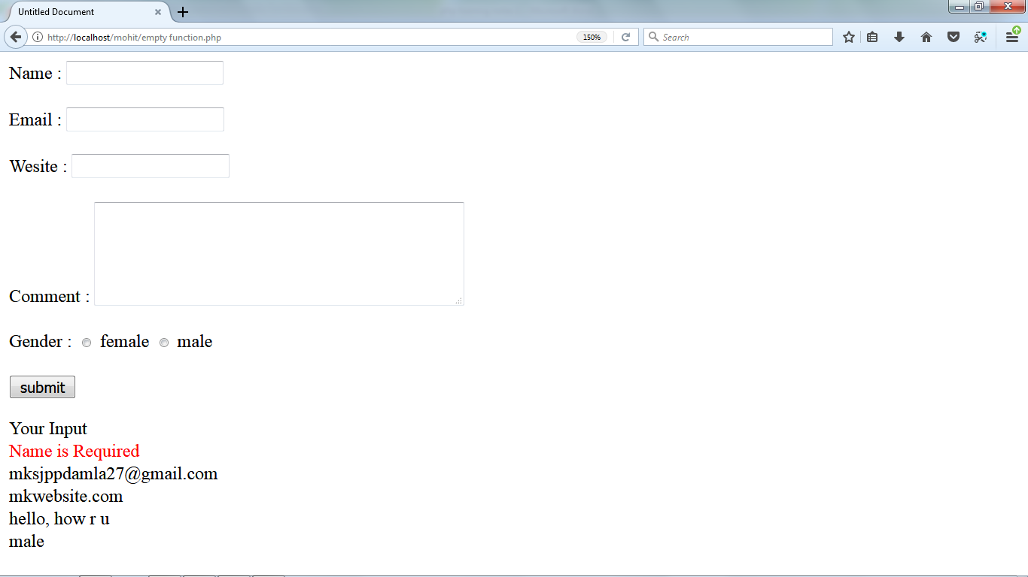

**Mysqlseek function**

|  |
| --- |
| <?php  $conn = mysql_connect("localhost","root",""); //connect with server  mysql_select_db("test"); //select database  $rs=mysql_query("select *from std"); //query  mysql_data_seek($rs,2); //start from row no. 2  $row = mysql_fetch_array($rs); // get value from database  echo $row[0]; //show value from db  ?> |

**True False Condition**

|  |
| --- |
| <?php  $rs=mysql_fetch_array(mysql_query("select *from addsub where sub='$addsub';"));  If($rs==true){  echo “true”;  }  else{  echo “false”;  }  ?> |

**Select any input tag**

|  |
| --- |
| <html>  <head>  <title>select any tag</title>  <?php  $conn=mysql_connect("localhost","root","");  mysql_select_db("naam",$conn);  if(isset($_POST['smt'])){  if($_POST['smt']=="save"){  echo "Saved";  }  else{  mysql_query("update addsub set test='$_POST[addtest]' where sub='$_POST[subid]'");  echo $_POST['addtest']." of ".$_POST['subid'];  }  }  ?>  </head>  <body>  <form method="post" action="#">  <select name="subid">  <option value="java">Java</option>  <option value="cip">cip</option>  </select>  <input type="text" name="addtest" />  <input type="submit" value="Submit" name="smt"/>  <input type="submit" value="save" name="smt"/>  </form>  </body>  </html> |